Team Members:
Tirumalasetty Chandrika (team lead)
Likhitha Kaja
Venkata Ram Charan Seelamsetti
Reethi Tungala

Title:Food Delivery Data Analysis Using Tableau

1. Introduction
The food delivery industry has experienced significant growth in recent years due to rapid urbanization, increased smartphone usage, and the convenience of online ordering. Customers can order food from a variety of restaurants through online platforms and have it delivered to their doorstep within a short period. As the number of daily orders increases, food delivery companies generate large volumes of data containing valuable information about customer preferences, order trends, delivery performance, and revenue.
Managing and analyzing such a large amount of data manually is difficult. Data visualization tools such as Tableau help convert raw data into interactive dashboards, making it easier to identify trends and patterns. This project focuses on analyzing food delivery data using Tableau to provide meaningful insights that support business decision-making and improve customer satisfaction.

2. Problem Statement
Food delivery companies collect a large amount of customer and order data every day. However, simply storing data is not enough to improve business performance. Businesses need to understand which cities generate the highest number of orders, which cuisines are most popular, how delivery time affects customer satisfaction, and which meal types are preferred by customers.
Without proper analysis, companies face difficulties in understanding customer behavior, optimizing delivery operations, increasing revenue, and improving overall service quality. Therefore, there is a need for an interactive analytical solution that transforms raw data into meaningful visualizations for effective decision-making.

3. Objectives
The main objectives of this project are:
- To analyze food delivery order data using Tableau.
- To understand customer ordering behavior.
- To identify the most popular cuisines and meal types.
- To analyze city-wise order demand.
- To evaluate delivery performance using delivery time analysis.
- To identify revenue trends across different cities.
- To create interactive dashboards for business analysis.
- To support data-driven business decisions.

4. Scope of the Project
This project is designed to analyze food delivery data collected from different cities. The analysis helps businesses understand customer preferences, operational efficiency, and sales performance. The dashboards provide real-time insights through interactive charts and filters, enabling users to explore the data easily.
The project can be extended by integrating live data from food delivery platforms and incorporating advanced analytics such as demand forecasting, customer segmentation, and predictive analysis.

5. Dataset Description
The project uses a food delivery dataset containing information about customer orders. Each record represents a single food order and includes various attributes related to the transaction.

Dataset Fields
Field | Description
Order ID | Unique identification number for each order
Order Date | Date on which the order was placed
City | Location where the order was placed
Cuisine | Type of food ordered
Meal Type | Breakfast, Lunch, Dinner, or Snacks
Order Value | Total amount paid by the customer
Delivery Fee | Delivery charge applied to the order
Time Taken for Delivery | Delivery time measured in minutes

6. Data Preprocessing
Before visualization, the dataset was cleaned and prepared for analysis.
The preprocessing steps included:
- Importing the dataset into Microsoft Excel.
- Checking for duplicate records and removing them.
- Identifying missing values and correcting them.
- Ensuring correct data types for numerical and categorical fields.
- Standardizing city names and cuisine categories.
- Formatting dates into a consistent format.
- Verifying data accuracy before importing into Tableau.
These preprocessing steps improved data quality and ensured accurate analysis.

7. Tools and Technologies Used

Tableau Public
Used for creating interactive dashboards, charts, stories, and visual analytics.

Microsoft Excel
Used for storing, organizing, cleaning, and preparing the dataset.

GitHub
Used for hosting project files and maintaining version control.

8. Methodology
The project follows a systematic analytical process:
- Data Collection
- Data Cleaning
- Data Preparation
- Data Import into Tableau
- Dashboard Development
- Story Creation
- Insight Generation
- Report Preparation
- GitHub Repository Creation
- Tableau Public Dashboard Publishing

9. Dashboard Description
The Tableau dashboard contains several visualizations that provide meaningful business insights.

KPI Cards
The dashboard displays key performance indicators including:
- Total Orders
- Total Revenue
- Average Order Value
- Average Delivery Time

Orders by City
A bar chart compares the total number of orders across different cities.

Revenue by City
This visualization identifies cities generating the highest revenue.

Cuisine Popularity
A pie chart illustrates the distribution of different cuisine types ordered by customers.

Meal Type Analysis
This chart compares customer preferences for breakfast, lunch, dinner, and snacks.

Delivery Time Distribution
A histogram displays the distribution of delivery times.

Interactive Filters
Users can filter the dashboard by city, cuisine, meal type, and date.
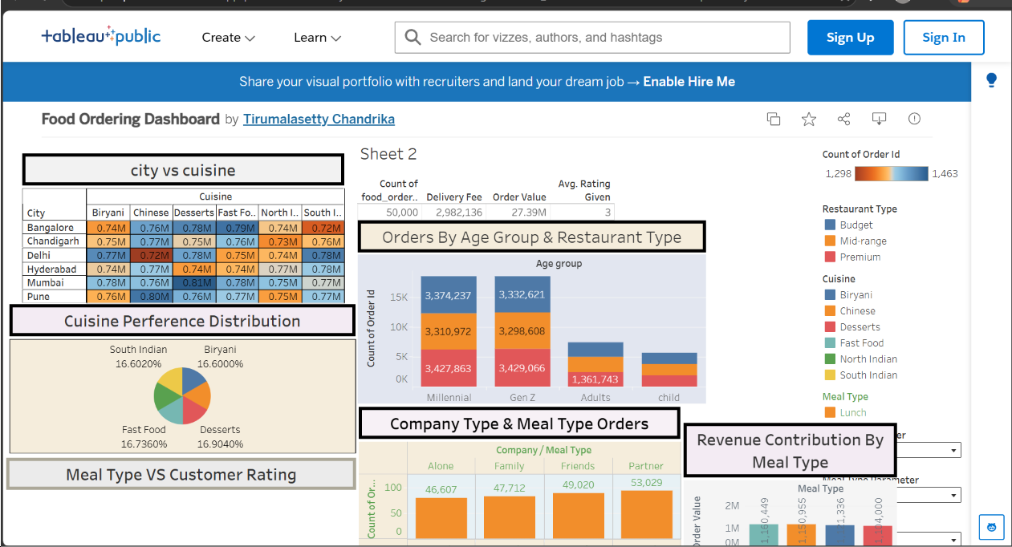

10. Business Scenarios

Scenario 1 – Rahul Sharma (Business Analyst)
Rahul Sharma uses Tableau dashboards to analyze order trends, customer preferences, city-wise demand, and revenue generation. He identifies business opportunities and recommends strategies for increasing sales and improving customer satisfaction.

Scenario 2 – Priya Mehta (Operations Manager)
Priya Mehta focuses on improving operational efficiency by analyzing delivery times, identifying delays, and monitoring workload across different cities. Her analysis helps optimize delivery resources and reduce service delays.

Scenario 3 – Neha Reddy (Customer)
Neha Reddy represents a regular customer who values quick delivery, affordable pricing, and food variety. Her purchasing behavior reflects customer expectations and helps businesses understand customer satisfaction.

11. Key Insights
The analysis provides several important insights:
- Certain cities generate significantly higher order volumes.
- Popular cuisines contribute a large share of total orders.
- Dinner is the busiest meal period.
- Delivery time directly affects customer satisfaction.
- Higher order values contribute more to business revenue.
- Interactive dashboards simplify business decision-making.

12. Benefits of the Project
- Improves business decision-making.
- Helps understand customer behavior.
- Identifies high-performing cities.
- Enhances operational efficiency.
- Supports revenue growth.
- Improves delivery performance.
- Provides interactive visual analytics.
- Reduces manual reporting effort.

13. Future Scope
The project can be enhanced by:
- Integrating live data from food delivery platforms.
- Using machine learning to predict future demand.
- Performing customer segmentation.
- Developing mobile dashboards.
- Integrating real-time GPS delivery tracking.
- Building predictive models for delivery time estimation.

14. Conclusion
The Food Delivery Data Analysis Using Tableau project demonstrates how business intelligence tools can transform raw data into meaningful insights. By analyzing customer behavior, order trends, delivery performance, and revenue, the project provides valuable information that supports business growth and operational efficiency.
The interactive dashboards enable decision-makers to identify opportunities, monitor performance, and improve customer satisfaction. This project highlights the importance of data visualization in modern business environments and serves as a foundation for future analytical applications.

